
Daffodil International University
Department of Software Engineering
19 Oct 2025
OVERLAP EXAM NOTICE FOR Mid/Final-Term
EXAMINATION Fall 2025

Students of Department of Software Engineering are hereby notified that the
Overlap Examination of Mid/Final Fall 2025 will be held on according to main routine schedule. Check the Mid/Final Exam Routine.
All students are advised to submit an application within 15-12-2025 to the Software Engineering Department Office (Ms. Jui Jenifer Gomes, Assistant Coordination Officer) with the signature of the both course teachers which are overlapped with each other and signature of the batch adviser also.
***Two Examinations in the same day but at different time slots will not be considered as Overlap Examination.

No student will be allowed to sit without application or fake application. If found, the answer script will be rejected by the Exam committee member.

Overlap Exam Policy (Applicable for Midterm & Final Examination)
- Collect the Overlap Form
  - Visit the Department Office and collect the Overlap Form from
Ms. Jui Jenifer Gomes, Assistant Coordination Officer.
- Fill Out the Form
  - Provide all required information accurately.
- Get Necessary Signatures
  - Take signatures from both your Course Teacher and Mentor.
- Submit the Form
  - Submit the completed form to the Department Office (Ms. Jui Jenifer Gomes).
- Check Overlap Routine
* Visit the SWE Web Notice Portal for Overlap Exam Routine.

Demographic View: 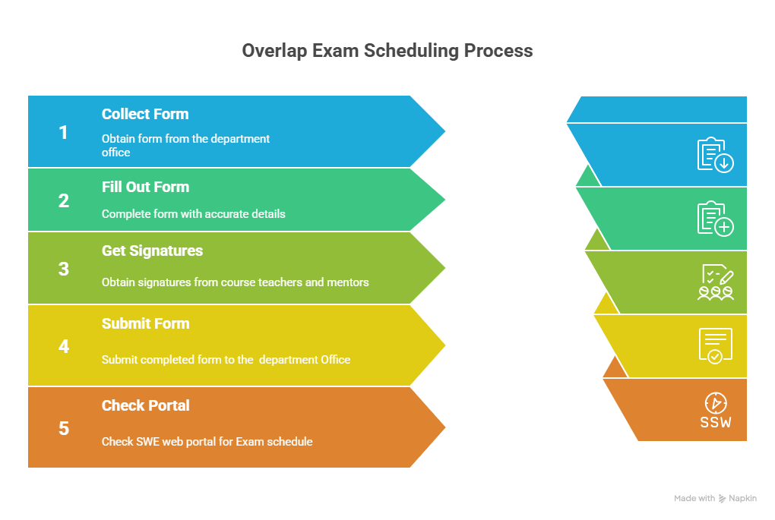

Improvement Exam Policy (Applicable for Final Examination only)
- Wait for Official Notice
  - Wait for the DIU Improvement Exam Notice sent to your DIU Student Mail.
- Collect the Improvement Form
  - Collect the form from the Department Office (Ms. Jui Jenifer Gomes, Assistant Coordination Officer).
- Fill Out the Form
  - Complete all required information accurately.
- Get Signature and Make Payment
  - Take the signature of your Course Teacher & Mentor.
  - Make the required payment at the Accounts Section and obtain the seal from Accounts.
- Submit the Form
  - Submit the completed form to the Department Office (Ms. Jui Jenifer Gomes).
- Check Notice Portal
- Visit the SWE Web Notice Portal regularly for updates regarding Exam schedules.
Demographic View:

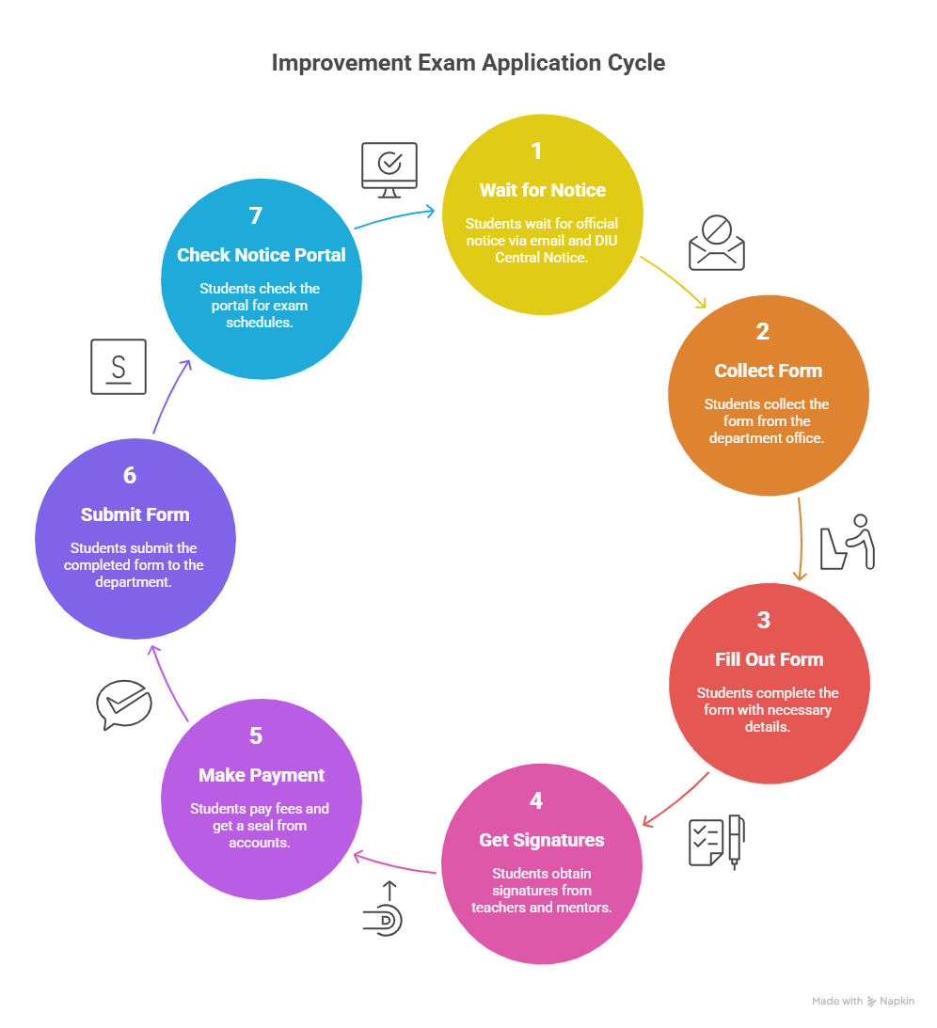

Special Case: (Applicable for Midterm & Final Examination)
If you miss your exam (mid-term or final-term) for other reason, asked to send email to sweoffice3@daffodilvarsity.edu.bd keep cc your academic mentor/advisor with valid prove documents. Then wait for the confirmation whether you allow or not.

Overlap Mid/Final-Term Exam Application Format

...................... (Write Date Here)

To
The Member of Exam Committee,
Department of Software Engineering
Daffodil International University
Daffodil Smart City. Birulia, Savar Dhaka 1216.

Subject: Application for attending the Overlap of Mid/Final Exam in Fall 2025.

Dear Sir,

I am (Name) , a regular student in your university. My (which semester you are) semester final

exam routine is published. This time after getting my exam routine I have noticed that two of my courses

are in the same day as well as the same time slot. It is not possible for me to attend two courses at the same time.
Details for Overlap course:
Acknowledgement | Course Code | Course title | Teacher Initial | Teacher Signature
I will attend this course of overlap exam.
I will attend this course at schedule time.
I am informed that  My student is  attending Overlap  Examination | Name of Adviser:  Advisor Comment : |  |  | Signature of Adviser :

Therefore, I pray and hope that you will be kind enough to permit me to attend an overlap course at the time of overlap / Improvement.

Yours Obediently,

Student Name:

Student ID:

Section:

Batch:

Mobile:
Email:

