Daffodil International University
Department of Software Engineering (SWE)
Project/Thesis Committee

NOTICE
Submission of Final Year Project/Thesis Proposal
For 41st Batch Students
This is to notify all eligible students of the 41st Batch that they are required to submit their Final Year Project/Thesis proposal by 04/06/2026. To submit the proposal, students must fill in the prescribed proposal form and follow the instructions below.

Google Classroom: Before following the instructions, students are requested to join the Google Classroom related to Eligibility for Thesis/Project/Internship. Further instructions and updates will be shared there.
cse5fd5y

Eligibility and Guidelines
- Credit Completion Requirement: Students who are going to complete 95 to 105 credits in the Spring 2026 semester are eligible to submit a proposal for the Final Year Project/Thesis.

- Thesis (General): Students must have a minimum CGPA of 3.00 to apply for Thesis. For students with a CGPA below 3.00, the Department and the Project/Thesis Committee will decide based on fixed criteria.

- Project (General): Any student may take a Project. However, the project must follow the Software Development Life Cycle (SDLC). The Department highly discourages common or old-style management system projects. Students must have knowledge of both back-end and front-end development.

- Project (Industry): Students must have a minimum CGPA of 3.00 and must work in a renowned software company. The industry project must follow SDLC steps. The minimum duration is 4 months, and students must submit an appointment letter to the Project/Thesis Committee. After reviewing all criteria, the Committee will inform students of the decision. If the result is negative, the student must take a general project to complete the degree.

- Thesis (Industry): Students must have a minimum CGPA of 3.00 and must work in a renowned software company for the industry thesis. After reviewing all criteria, the Project/Thesis Committee will inform students of the decision. If the result is negative, the student must take a project to complete the degree.

- Individual Work Only: No group work is allowed. Each student must complete the Project/Thesis individually.
Important Note
- Students are instructed to read all guidelines carefully before submitting the proposal.
- Incomplete or incorrect submissions may not be considered by the Project/Thesis Committee.
- Students must submit the proposal within the deadline.
Thank you for your cooperation.

Project/Thesis Committee
Department of Software Engineering
For any assistance regarding Project/Thesis proposal submission, students are requested to contact us through the following email:
projectthesis.swe@diu.edu.bd
Students are requested to follow the guidelines below carefully for submitting their Project/Thesis Proposal through the Project/Thesis website:
https://swe.application.daffodilvarsity.edu.bd/final_project/public/login

1. Go to website (http://swe.application.daffodilvarsity.edu.bd/final_project/public/register)
2. Complete Registration (Fill up Name, Valid email address, Password)
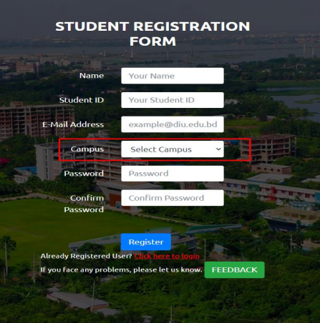.

3. If you are already registered you can be logged in using your student email id and your password.
Url: http://swe.application.daffodilvarsity.edu.bd/final_project/public/login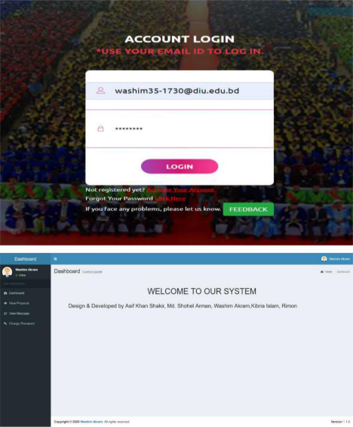

4. Submit your Proposal Click Here:
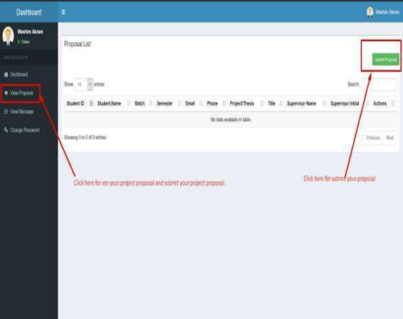

5. Fill up the proposal form and click submit button. (Fill up Student ID, Batch, Semester, Phone Number, Study, CGPA, Project/Thesis/Internship, Title, Description.)
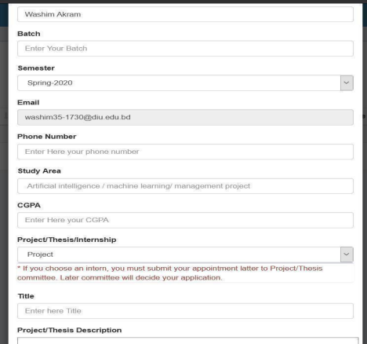

6. Click View proposal button and see your proposal accepted or pending.
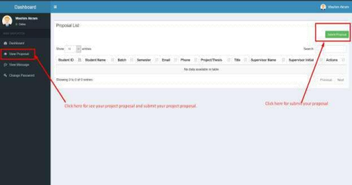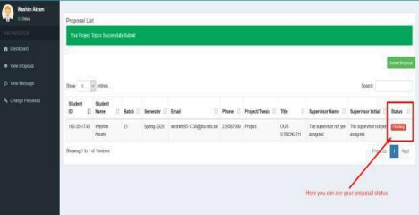

7. Click view message button and you can see your task.
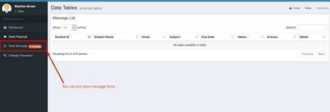
8. Click view details button then you can see details task.
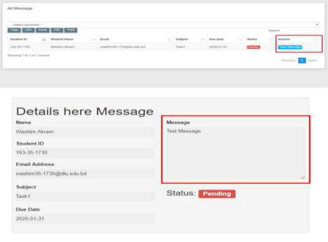

9. Here you can see notice.
